**Preparing the Camera Ready Paper**

**for TEM Journal**

First Author 1, Second Author 2, Third Author 3

*1First affiliation, Address, City, Country (e-mail)*

*2Second affiliation, Address, City, Country (e-mail)*

*3Third affiliation, Address, City, Country (e-mail)*

*Abstract –* In this paper are given the instructions for preparing camera ready paper for the TEM Journal. The recommended, but not limited text processor is Microsoft Word (docx). Insert an abstract of 50-100 words, giving a brief account of the most relevant aspects of the paper. It is recommended to use up to 5 keywords.

*Keywords –* Camera ready paper, TEM Journal.

1. **Introduction**

In order to affect high quality of the papers, the authors are requested to follow instructions given in this sample paper. Regular length of the paper is 5 to 12 pages.

1. **Instructions for the authors**

Times New Roman 11 point’s font should be used for normal text. The manuscript has to be prepared in two columns separated by 5 mm. The margins for A4 (210×297 mm2) paper are given in Table 1.

Regular paper may be divided in a number of sections. Section titles (including references and acknowledgements) should be typed using 11 pt fonts with **bold** option.

DOI: 10.18421/TEMxx-xx

<https://doi.org/10.18421/TEMxx-xx>

**Corresponding author: -** ,

*affiliation*

**Email:** -

*Received: -----.*

*Revised: -----.*

*Accepted: -----.*

*Published: -----.*

Description: Description: Description: Description: Description: Description: Description: by-nc-nd-.png© 2023. ----; published by UIKTEN. This work is licensed under the Creative Commons Attribution-NonCommercial-NoDerivs 4.0 License.

The article is published with Open Access at <https://www.temjournal.com/>

*Table 1. Page layout description*

|  |  |  |
| --- | --- | --- |
| Paper size | A4 |  |
| Top margin | 20 mm |  |
| Bottom margin | 20 mm |  |
| Left margin | 20 mm |  |
| Right margin | 18 mm |  |
| Column Spacing | 5 mm |  |

Sections can be split in subsections, which should be typed in 10 pt *Italic* options. Figures should be one column wide. If it is impossible to place the figure in one column, two column width figure is allowed. Each figure must have a caption under the figure. For the figure captions 10 pt font should be used.

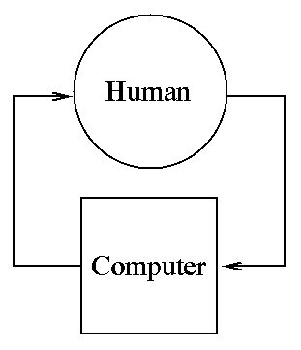

*Figure 1. Text here*

1. **Conclusion**

Be brief and state the most important conclusions from your paper. Do not use equations and figures here.

Acknowledgements (If any)

These and the Reference headings are in bold but have no numbers.

**References** – (avoid links as much as you can), format references in the APA style. Example:

1. Wong, B., & Kokko, H. (2005). Is science as global as we think?. *Trends in ecology & evolution*, *20*(9), 475-476.
2. Haykin, S. (1994). *Neural networks: a comprehensive foundation*. Prentice Hall PTR.
3. Hennessy, J. L., & Patterson, D. A. (2012). *Computer architecture: a quantitative approach*. Elsevier.
4. FESTO. (2019). Fluidic Muscle DMSP/MAS. Retrieved from:

<https://www.festo.com/rep/en_corp/assets/pdf/info_501_en.pdf> [accessed: 19 September 2021].